OKTOBERFEST 2016
Mercedes Benz Club of the Central Coast
JOIN US FOR BRATWURST, BIER AND MUSIK!!!
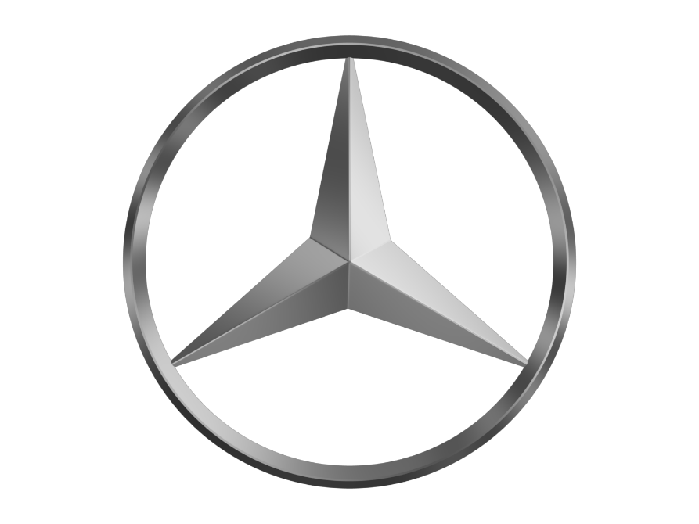
September 24, 2016 12-4pm $20 per person
Where: 956 Griffin St. Grover Beach, CA
RSVP: tracydelrio@gmail.com or lemosliz@gmail.com or
Call Tracy 805-801-9476 or Liz 805-459-5103

